What is marriage?

Mark 7:7
Howbeit in vain do they worship me, teaching for doctrines the commandments of men.

Our perspective can easily be twisted and wrong because of the lies that the world teaches us. Sometimes, those lies become entrenched in our tradition and if we’re not careful they creep into the body of Christ (the Church).

Be vigilant and continually remember that the world is the enemy of God. They will continue to pervert God’s ways until the return of the Lord Jesus Christ.

James 4:4
Ye adulterers and adulteresses, know ye not that the friendship of the world is enmity with God? whosoever therefore will be a friend of the world is the enemy of God.

If we aren’t careful we can then accept that tradition as truth which then causes us to err in our judgment.

In the following example we’re going to look at a tradition that is so deeply embedded into human culture and nearly every nation on the planet that you might even be offended, hurt, or upset to learn that we’ve so easily accepted this lie hook, line, and sinker for thousands of years. Prepare yourself for that.

Take the following scenario:

A virgin, “unmarried in the traditional sense”, man and woman have intercourse together. Most people would condemn them and say “you need to get married” and most other people would agree with them. Unfortunately for those deceived people: the couple is already married. Therefore, those people have condemned the guiltless.

Seems contradictory right? They need to get married but they’re already married. That’s because it is. In that example there are two ideals at odds with each other: one is of the world and the other is of God. One is wrong and one is right. The important question to ask yourself is, which is which?

Let’s start with the easy part that we all know because we’ve all been taught the same from birth. It’s so ingrained into human culture that every nation on the planet seems to have evolved their own style of it (anything ecumenical should immediately raise a red flag. Matthew 10:34).

So, how does the world define marriage? It usually involves a feast, a ritual, and then some licensed official declares the couple married (a wedding ceremony).

Now they’re married right? In the eyes of the world? Yes. But, in the eyes of God? No.

Genesis 2:21-25
²¹ And the LORD God caused a deep sleep to fall upon Adam, and he slept: and he took one of his ribs, and closed up the flesh instead thereof;
²² And the rib, which the LORD God had taken from man, made he a woman, and brought her unto the man.
²³ And Adam said, This is now bone of my bones, and flesh of my flesh: she shall be called Woman, because she was taken out of Man.
²⁴ Therefore shall a man leave his father and his mother, and shall cleave unto his wife: and they shall be one flesh.
²⁵ And they were both naked, the man and his wife, and were not ashamed.

Do take note that v24 is all future tense (it’s not chronologically speaking about Adam & Eve but instead it speaks towards all men) and it’s a three step process:

- The man leaves his father and his mother.
- He cleaves unto his wife.
  - Cleave: to take, keep, stay close to, join together, follow closely, stick together. The word “cleave” does not communicate intercourse it is simply a close partnership.
- The man and his wife become one flesh .
  - This is the physical joining, what we would call intercourse, mating, copulation, or sex.

v25 is where things get interesting. It’s the first time that Eve is called Adam’s wife in the past tense. That means at that point in time God considered Adam and Eve to be husband and wife (married). No ritual, no papers, and also no intercourse that we know of from this context*.

The phrase “one flesh” appears seven times in six verses in the Bible: Genesis 2:24, Matthew 19:5,6, Mark 10:8, 1 Corinthians 6:16, Ephesians 5:31. Every one of them contributes something to the idea of what it means to be “one flesh”.

Genesis 2:24  Therefore shall a man leave his father and his mother, and shall cleave unto his wife: and they shall be one flesh. | When a man and woman stick close together they (future tense) shall be one flesh.  What naturally happens when a man and a woman stick very close to each other for any length of time? Whether they actually perform the act of intercourse together or not they certainly at least think about it. That “natural attraction” is exactly why men and woman feel the need to be “separated” from each other.
Matthew 19:3-6  ³ The Pharisees also came unto him, tempting him, and saying unto him, Is it lawful for a man to put away his wife for every cause?  ⁴ And he answered and said unto them, Have ye not read, that he which made them at the beginning made them male and female,  ⁵ And said, For this cause shall a man leave father and mother, and shall cleave to his wife: and they twain shall be one flesh?  ⁶ Wherefore they are no more twain, but one flesh. What therefore God hath joined together, let not man put asunder. | God does the joining (the context is physical).
Mark 10:2-9  ² And the Pharisees came to him, and asked him, Is it lawful for a man to put away his wife? tempting him.  ³ And he answered and said unto them, What did Moses command you?  ⁴ And they said, Moses suffered to write a bill of divorcement, and to put her away.  ⁵ And Jesus answered and said unto them, For the hardness of your heart he wrote you this precept.  ⁶ But from the beginning of the creation God made them male and female.  ⁷ For this cause shall a man leave his father and mother, and cleave to his wife;  ⁸ And they twain shall be one flesh: so then they are no more twain, but one flesh.  ⁹ What therefore God hath joined together, let not man put asunder. | Something happens when a man and a woman stick close to each other that causes them to go from “two fleshes” (twain) to “one flesh”.  God does the joining (the context is physical).
1 Corinthians 6:15-16  ¹⁵ Know ye not that your bodies are the members of Christ? shall I then take the members of Christ, and make them the members of an harlot? God forbid.  ¹⁶ What? know ye not that he which is joined to an harlot is one body? for two, saith he, shall be one flesh. | *Two bodies joining together is the same as becoming “one flesh”. This also necessarily tells us that chronologically Genesis 4:1a occurred before Genesis 2:25.  This is the most explicit verse that tells us that “becoming one flesh” is the same as “joining together” which is the same as “intercourse/mating/copulating/sex”.
Ephesians 5:28-33  ²⁸ So ought men to love their wives as their own bodies. He that loveth his wife loveth himself.  29 For no man ever yet hated his own flesh; but nourisheth and cherisheth it, even as the Lord the church:  ³⁰ For we are members of his body, of his flesh, and of his bones.  ³¹ For this cause shall a man leave his father and mother, and shall be joined unto his wife, and they two shall be one flesh.  ³² This is a great mystery: but I speak concerning Christ and the church.  ³³ Nevertheless let every one of you in particular so love his wife even as himself; and the wife see that she reverence her husband. | Note that the context is husbands and wives (they’re already married).  A man should love, cherish, and nourish his wife as if it were is own flesh because they are one flesh.

And that’s all we really need to look at because try as we might we will never find in scripture God acknowledging a couple as husband and wife based on a feast, ceremony/ritual, and/or legal document.

Instead, until we get to the new testament

Isaac & Rebekah

Genesis 24:51-67
⁵¹ Behold, Rebekah is before thee, take her, and go, and let her be thy master's son's wife, as the LORD hath spoken.
…
⁶² And Isaac came from the way of the well Lahairoi; for he dwelt in the south country.
...
⁶⁷ And Isaac brought her into his mother Sarah's tent, and took Rebekah, and she became his wife; and he loved her: and Isaac was comforted after his mother's death.

If we go back one chapter we see that Abraham was dwelling in Hebron (Genesis 23:2). As far as we know, Abraham does not move from that location and is buried there in the same cave as his wife Sarah (Genesis 25:9,10). On the other hand, his son Isaac lived in the “south country” near to the well Lahai-roi.

Genesis 16:14
Wherefore the well was called Beer-lahai-roi; behold, it is between Kadesh and Bered.
Genesis 24:62
And Isaac came from the way of the well Lahai-roi; for he dwelt in the south country.
Genesis 25:11
And it came to pass after the death of Abraham, that God blessed his son Isaac; and Isaac dwelt by the well Lahai-roi.

In Hebrew “beer” means “well” or “pit”. In Genesis 24:62 and 25:11 that word is provided for us in English and so the prefix “beer” is not needed and wouldn’t make sense to include because “the well Beer-Lahai-Roi” would read “the well well Lahai-Roi”.

So why do we need to know all that? Genesis 16:14 tells us that that same well is “between Kadesh and Bered”. And that tells us that the “south country” that Isaac lived in was far to the southwest of Beer-Sheba. Isaac lived more than 25 miles away from his father Abraham, likely closer to 80 miles to the southwest but we can’t know for sure because the exact location of the well Lahai-Roi is debatable.

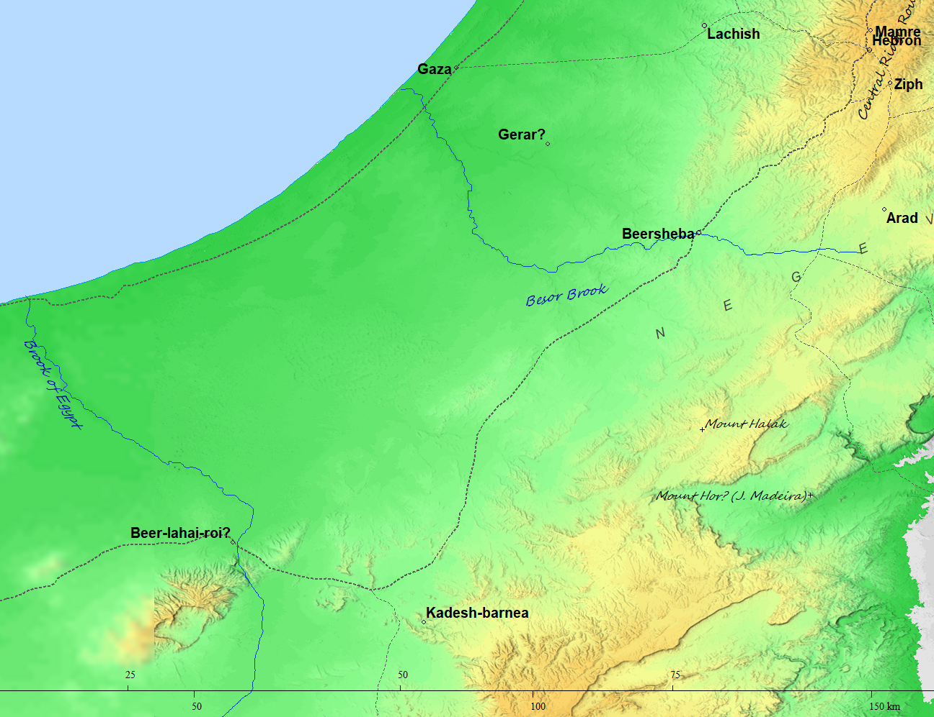
Now that we’ve gathered all that information from the Bible on Isaac and Rebekah let’s go back to the three step process found in Genesis 2:24.

Genesis 2:24
Step 1: Therefore shall a man leave his father and his mother,
Step 2: and shall cleave unto his wife:
Step 3: and they shall be one flesh.

Genesis 24:67
And Isaac brought her into his mother Sarah's tent, and took Rebekah, and she became his wife; and he loved her: and Isaac was comforted after his mother's death.

- Isaac leaves his father and his mother and dwells in the south country.
- Isaac cleaves to his wife Rebekah.
  - “And Isaac brought her into his mother Sarah's tent”
- Isaac & Rebekah have intercourse.
  - “and took Rebekah”
- Rebekah is now Isaac’s wife and they are married.
  - “and she became his wife”

And now that we have gathered the information we need from scripture we can look at the two ideals that clash with each other in the first example side by side:

Marriage
God’s eyes | Man’s eyes
One flesh, coming together, joining together, knowing one another, intercourse, copulation, mating, sex | A feast and/or a ceremony and/or a ritual and/or a legal document

When making any judgment (John 7:24), which do you think is right according to God?

Therefore, the next time we look at an “unmarried in the traditional sense” couple that have had intercourse together we should consider carefully God’s perspective first: they’re already married (whether that marriage was fornication or adultery is a different matter). The feasts, the ceremonies, the legal documents: none of that will count for anything in the judgment (Proverbs 29:26, Hebrew 9:27). What will matter is condemning innocent people.

